**Total World Emission,CO2 Emission over Time ,Total Emission by Continents:**

Total World Emission:

* Global energy-related CO2 emissions grew by 0.9% or 321 Mt in 2022, reaching a new high of over 36.8 Gt. Following two years of exceptional oscillations in energy use and emissions, caused in part by the Covid-19 pandemic, last year’s growth was much slower than 2021’s rebound of more than 6%. Emissions from energy combustion increased by 423 Mt, while emissions from industrial processes decreased by 102 Mt.
* In a year marked by energy price shocks, rising inflation, and disruptions to traditional fuel trade flows, global growth in emissions was lower than feared, despite gas-to-coal switching in many countries. Increased deployment of clean energy technologies such as renewables, electric vehicles, and heat pumps helped prevent an additional 550 Mt in CO2 emissions. Industrial production curtailment, particularly in China and Europe, also averted additional emissions.
* Specific challenges in 2022 contributed to the growth in emissions. Of the 321 Mt CO2 increase, 60 Mt CO2 can be attributed to cooling and heating demand in extreme weather and another 55 Mt CO2 to nuclear power plants being offline.
* CO2 growth in 2022 was well below global GDP growth of 3.2%, reverting to a decade-long trend of decoupling emissions and economic growth that was broken by 2021’s sharp rebound in emissions. Improvements in the CO2 intensity of energy use were slightly slower than the past decade’s average.
* Emissions from natural gas fell by 1.6% or 118 Mt, following continued tightening of supply exacerbated by Russia’s invasion of Ukraine. Reductions in emissions from gas were particularly pronounced in Europe (-13.5%). The Asia Pacific region also saw unprecedented reductions (-1.8%).
* Increased emissions from coal more than offset reductions from natural gas. Amid a wave of gas-to-coal switching during the global energy crisis, CO2 emissions from coal grew by 1.6% or 243 Mt, far exceeding the last decade’s average growth rate, and reaching a new all-time high of almost 15.5 Gt.
* Emissions from oil grew even more than emissions from coal, rising by 2.5% or 268 Mt to 11.2 Gt. Around half of the increase came from aviation, as air travel continued to rebound from pandemic lows, nearing 80% of 2019 levels. Tempering this increase, electric vehicles continued to gain momentum in 2022, with over 10 million cars sold, exceeding 14% of global car sales.
* The biggest sectoral increase in emissions in 2022 came from electricity and heat generation, whose emissions were up by 1.8% or 261 Mt. In particular, global emissions from coal-fired electricity and heat generation grew by 224 Mt or 2.1%, led by emerging economies in Asia.
* A strong expansion of renewables limited the rebound in coal power emissions. Renewables met 90% of last year’s global growth in electricity generation. Solar PV and wind generation each increased by around 275 TWh, a new annual record.
* Emissions from industry declined by 1.7% to 9.2 Gt last year. While several regions saw manufacturing curtailments, the global decline was largely driven by a 161 Mt CO2 decrease in China’s industry emissions, reflecting a 10% decline in cement production and a 2% decline in steel making.
* China’s emissions were relatively flat in 2022, declining by 23 Mt or 0.2%. Growing emissions from combustion were offset by declines from industrial processes. Weaker economic growth, declining construction activity, and strict Covid-19 measures led to reductions in industrial and transport emissions. Power sector emissions growth slowed compared with the average of the past decade but still reached 2.6%.
* The European Union saw a 2.5% or 70 Mt reduction in CO2 emissions despite oil and gas market disruptions, hydro shortfalls due to drought, and numerous nuclear plants going offline. Buildings sector emissions fell markedly, helped by a mild winter. Although power sector emissions increased by 3.4%, coal use was not as high as anticipated. For the first time, electricity generation from wind and solar PV combined exceeded that of gas or nuclear.
* US emissions grew by 0.8% or 36 Mt. The buildings sector saw the highest emissions growth, driven by extreme temperatures. The main emissions reductions came from electricity and heat generation, thanks to unprecedented increases in solar PV and wind, as well as coal-to-gas switching. While many other countries reduced their natural gas use, the United States saw an increase of 89 Mt in CO2 emissions from gas, as it was called upon to meet peak electricity demand during summer heat waves.
* Emissions from Asia’s emerging market and developing economies, excluding China, grew more than those from any other region in 2022, increasing by 4.2% or 206 Mt CO2. Over half of the region’s increase in emissions came from coal-fired power generation.

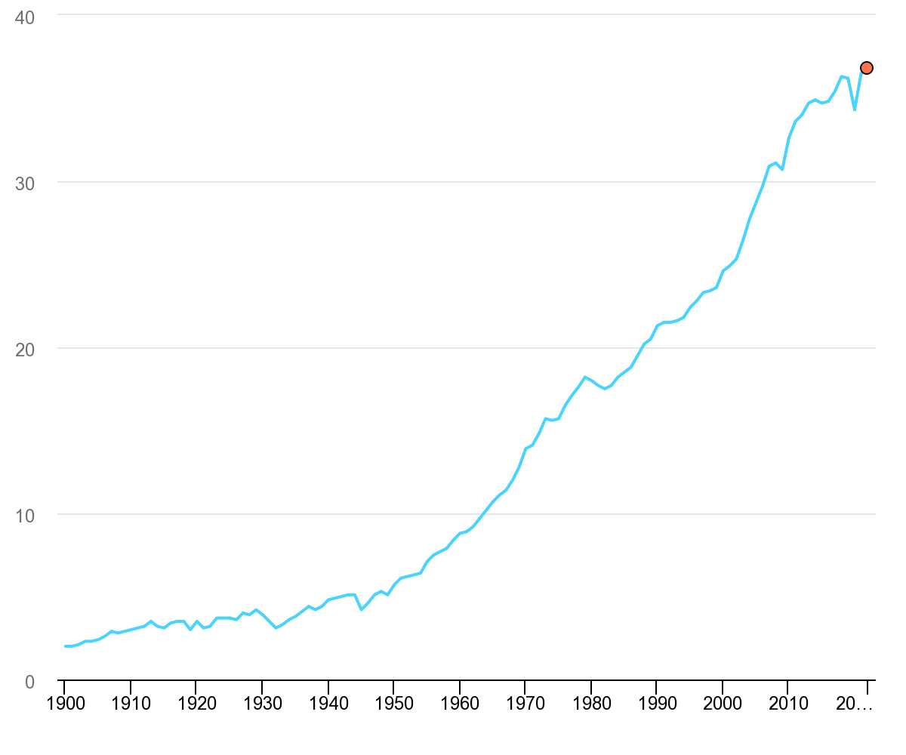

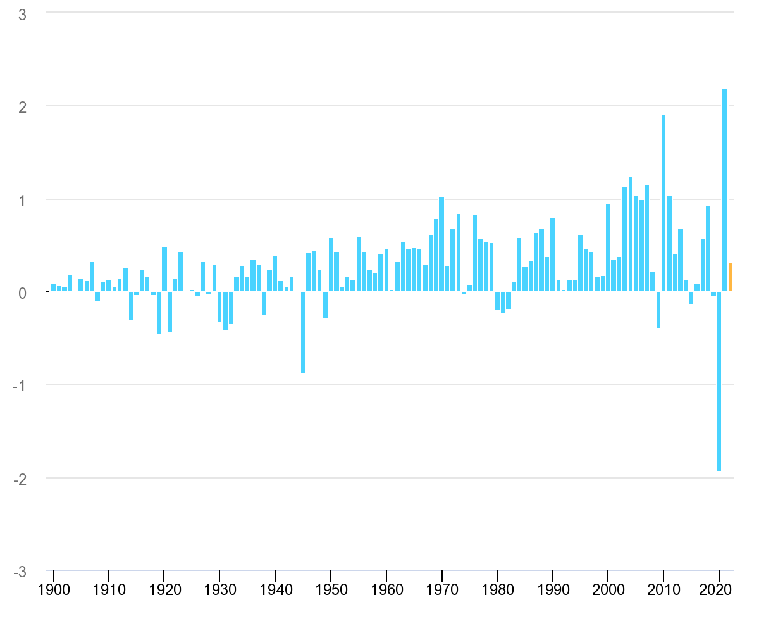

CO2 emissions from energy combustion grew by around 1.3% or 423 Mt in 2022, while CO2 emissions from industrial processes declined by 102 Mt. Emissions growth in 2022 was below global GDP growth (+3.2%), reverting to a decades-long trend of decoupling emissions and economic growth that was broken in 2021. Meanwhile, improvements in CO2 intensity of energy use were slightly slower than the past decade’s (2012-2021) annual average.

There were divergent trends between regions and sectors. CO2 emissions grew in North America and Asia (excluding People’s Republic of China [“China” hereafter]), outweighing reductions from Europe and China. At a global level, CO2 emissions from power and transport (including international bunkers) grew by 261 Mt and 254 Mt, respectively, more than offsetting reductions from industry and buildings.

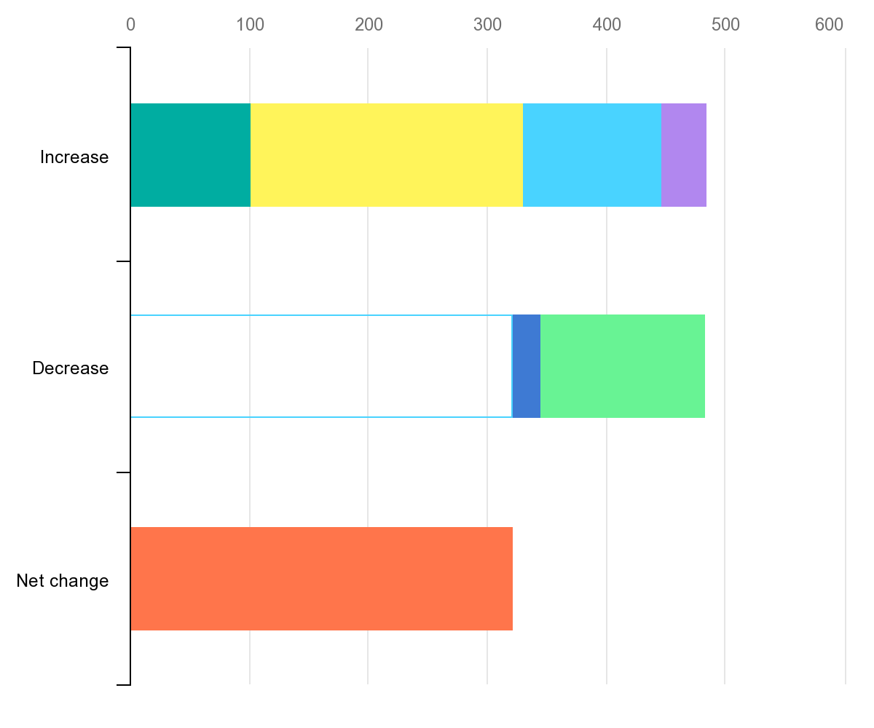

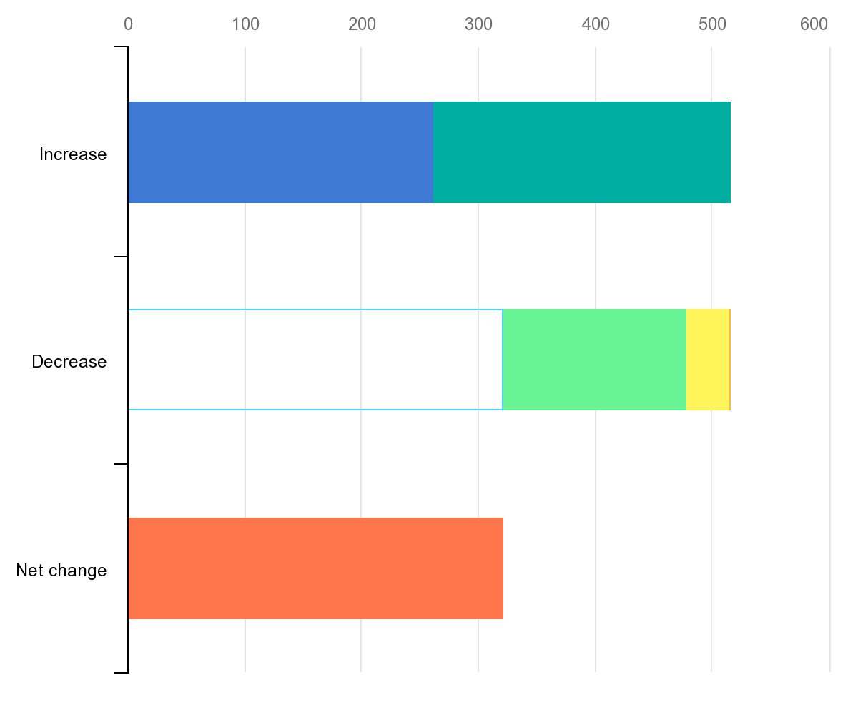

**CO2 Emission over Time :**

This interactive chart shows the breakdown of global CO2 emissions by region.

We see that until well into the 20th century, global emissions were dominated by Europe and the United States. In 1900, more than 90% of emissions were produced in Europe or the US; even by 1950, they accounted for more than 85% of emissions each year .But in recent decades this has changed significantly.

In the second half of the 20th century we see a significant rise in emissions in the rest of the world, particularly across Asia, and most notably, China.

The US and Europe now account for just under one-third of emissions.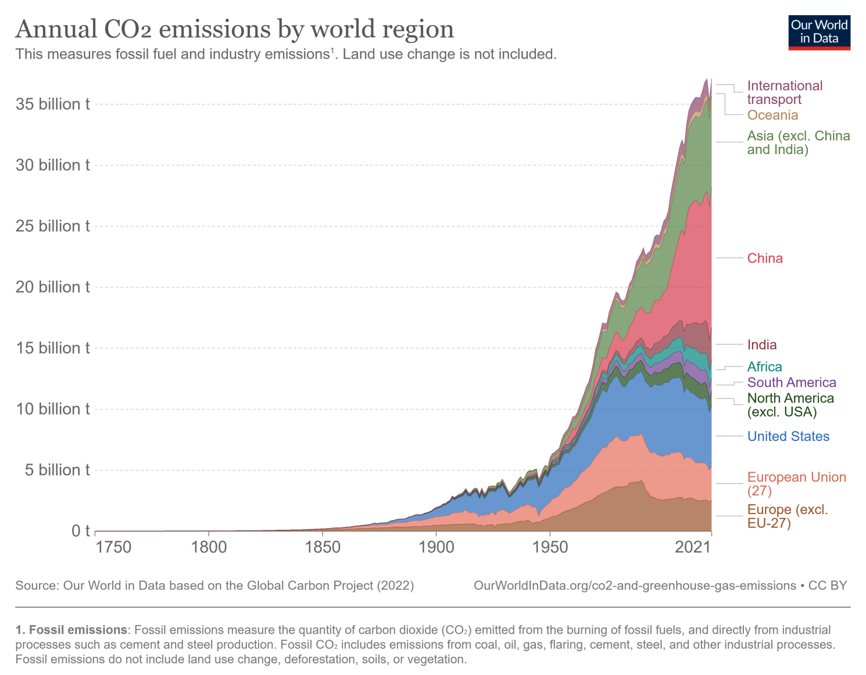

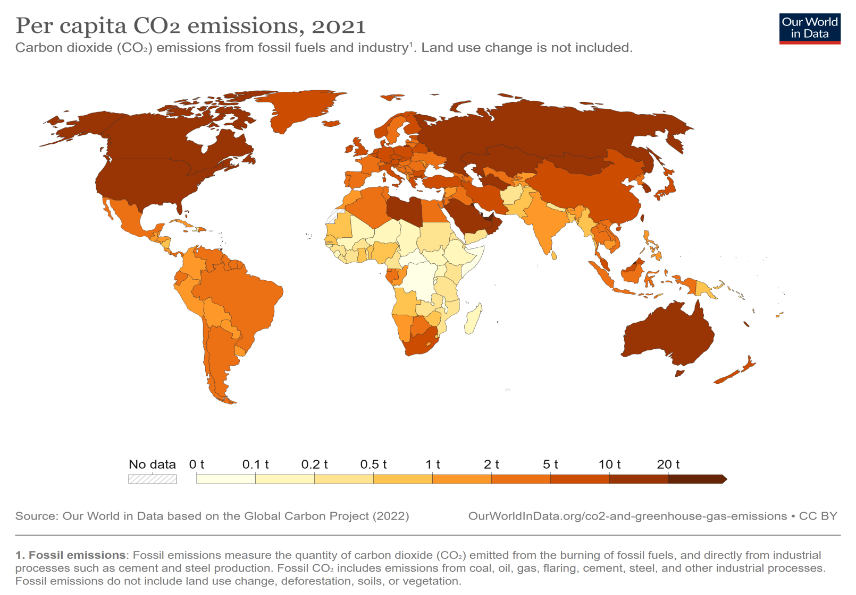

**Total Emission by Continents:**

